ECE 329
Laboratory Work-1
Flip Flops
Preparation:
1) Write characteristic tables of D flip flop, T flip flop and JK flip flop.
2) Consider the following signals and try to find the output signals.
For a D flip flop:
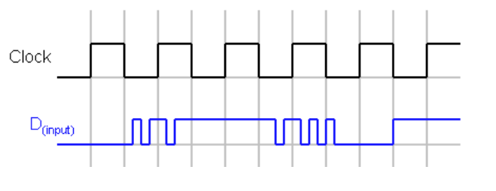
For a JK flip flop:

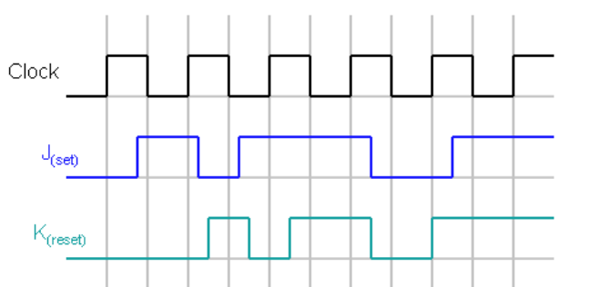

Experiment:
Design the circuits of D flip flop, use built_in D flipflop, T flip flop and JK flip flop using ORCAD P-SPICE. Finally check if they work correctly or not by giving different input signals according to your preparation.

